Shadow Ridge Christmas Show & Sale
Dec. 9 & 10, 2017 - 10 am to 4 pm

2145 Cnty Rd 3, PEC

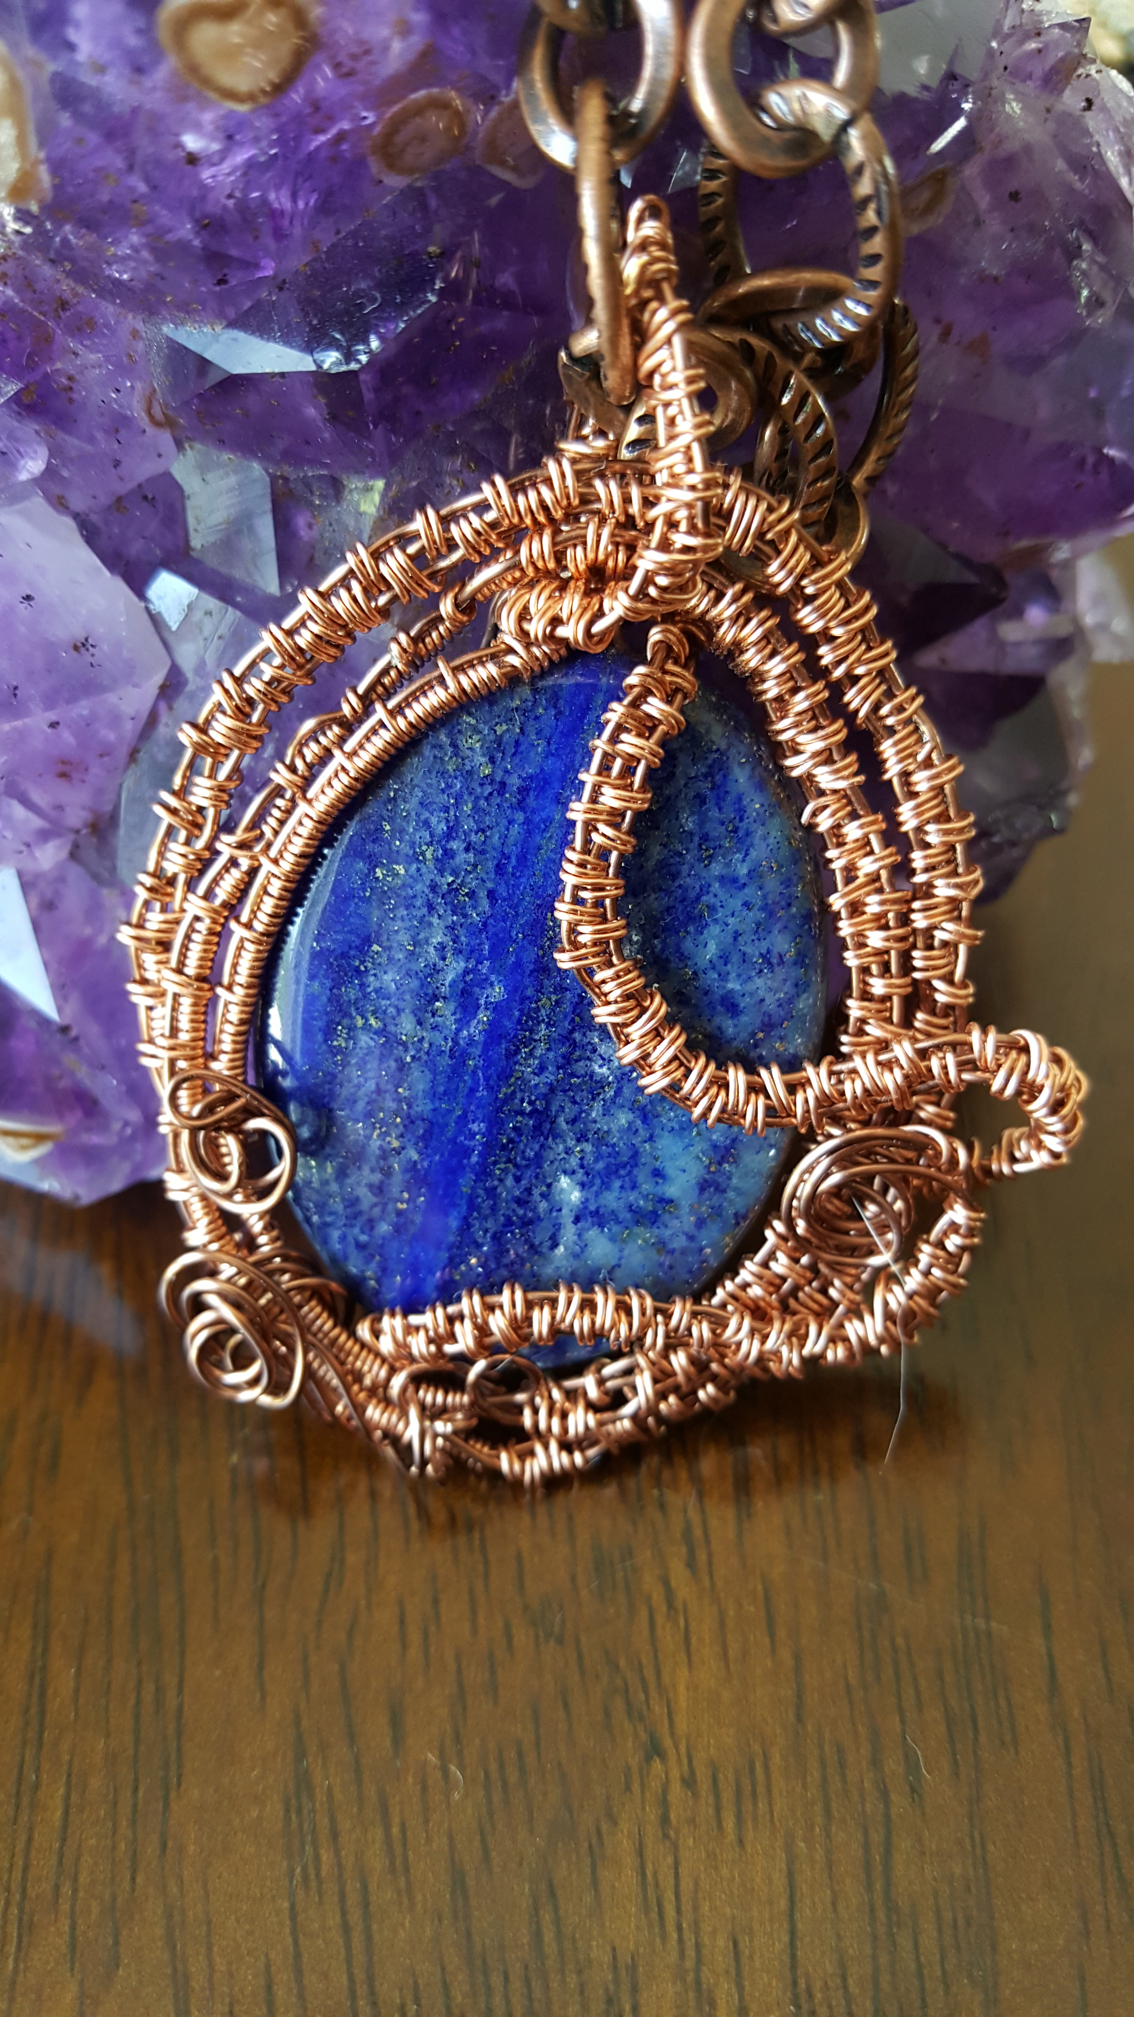 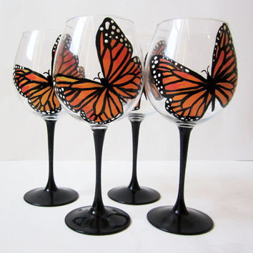 Jewellery, Wine Glasses, Visual & Garden Art, Natural Fiber Scarves

Christmas sales on Scarves, Leather Jewellery and complimentary gifts.

